* **Polynomial regression** - extends the linear model by adding extra predictors, obtained by raising each of the original predictors to a power
* Allows us to fit nonlinear data in a more flexible way
* Instead of the standard linear model we use the following function
* 
* When the degree is large enough a polynomial regression allows us to produce an extremely non-linear curve
* Imposes global structure across the full range of X’s with no tails



* The standard error of ˆf(x0) is the square-root of this variance. This computation is repeated at each reference point x0, and we plot the fitted curve

A screenshot of a cell phone

Description generated with very high confidence

* **Orthogonal Polynomial** –

- When looking for the best degree of polynomial you can use ANOVA because these are embedded models

- For a high degree polynomial fit, it is twice as fast

A close up of a map

Description generated with high confidence

* **Step Functions -** Cut the range of variables into bins



* + In the example above, if C1 is in the region we are interested in running the regression then it assumes the value of 1 and we get a coefficient of B1. Otherwise, C1 become 0 and the whole expression turns off or becomes 0. Note that only 1 C can assume the value of 1 at a time.
* Step functions avoid imposing a global structure in linear models
* The number of cut points controls basis variance tradeoff through cross-validation changing the number of cuts 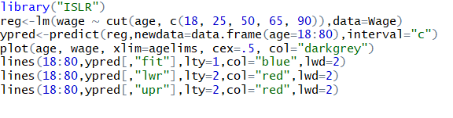

A picture containing screenshot

Description generated with very high confidence

* **Basis Functions**
* Polynomial and piecewise-constant regression models are examples of Basis Functions